**Chandler Ford | CSS 490 A   
PROGRAM 3 INSTRUCTIONS**

**Important: You need an existing Azure storage account and container to run this program.**

**Creating Azure storage account**

1. Log in to the Azure Portal
2. On the left side menu choose ***Storage accounts***
3. Click on ***Add***
4. Fill in the required fields on the ***Create storage account*** screen to create a StorageV2
5. Click on ***Review + create***
6. Click on ***Create***

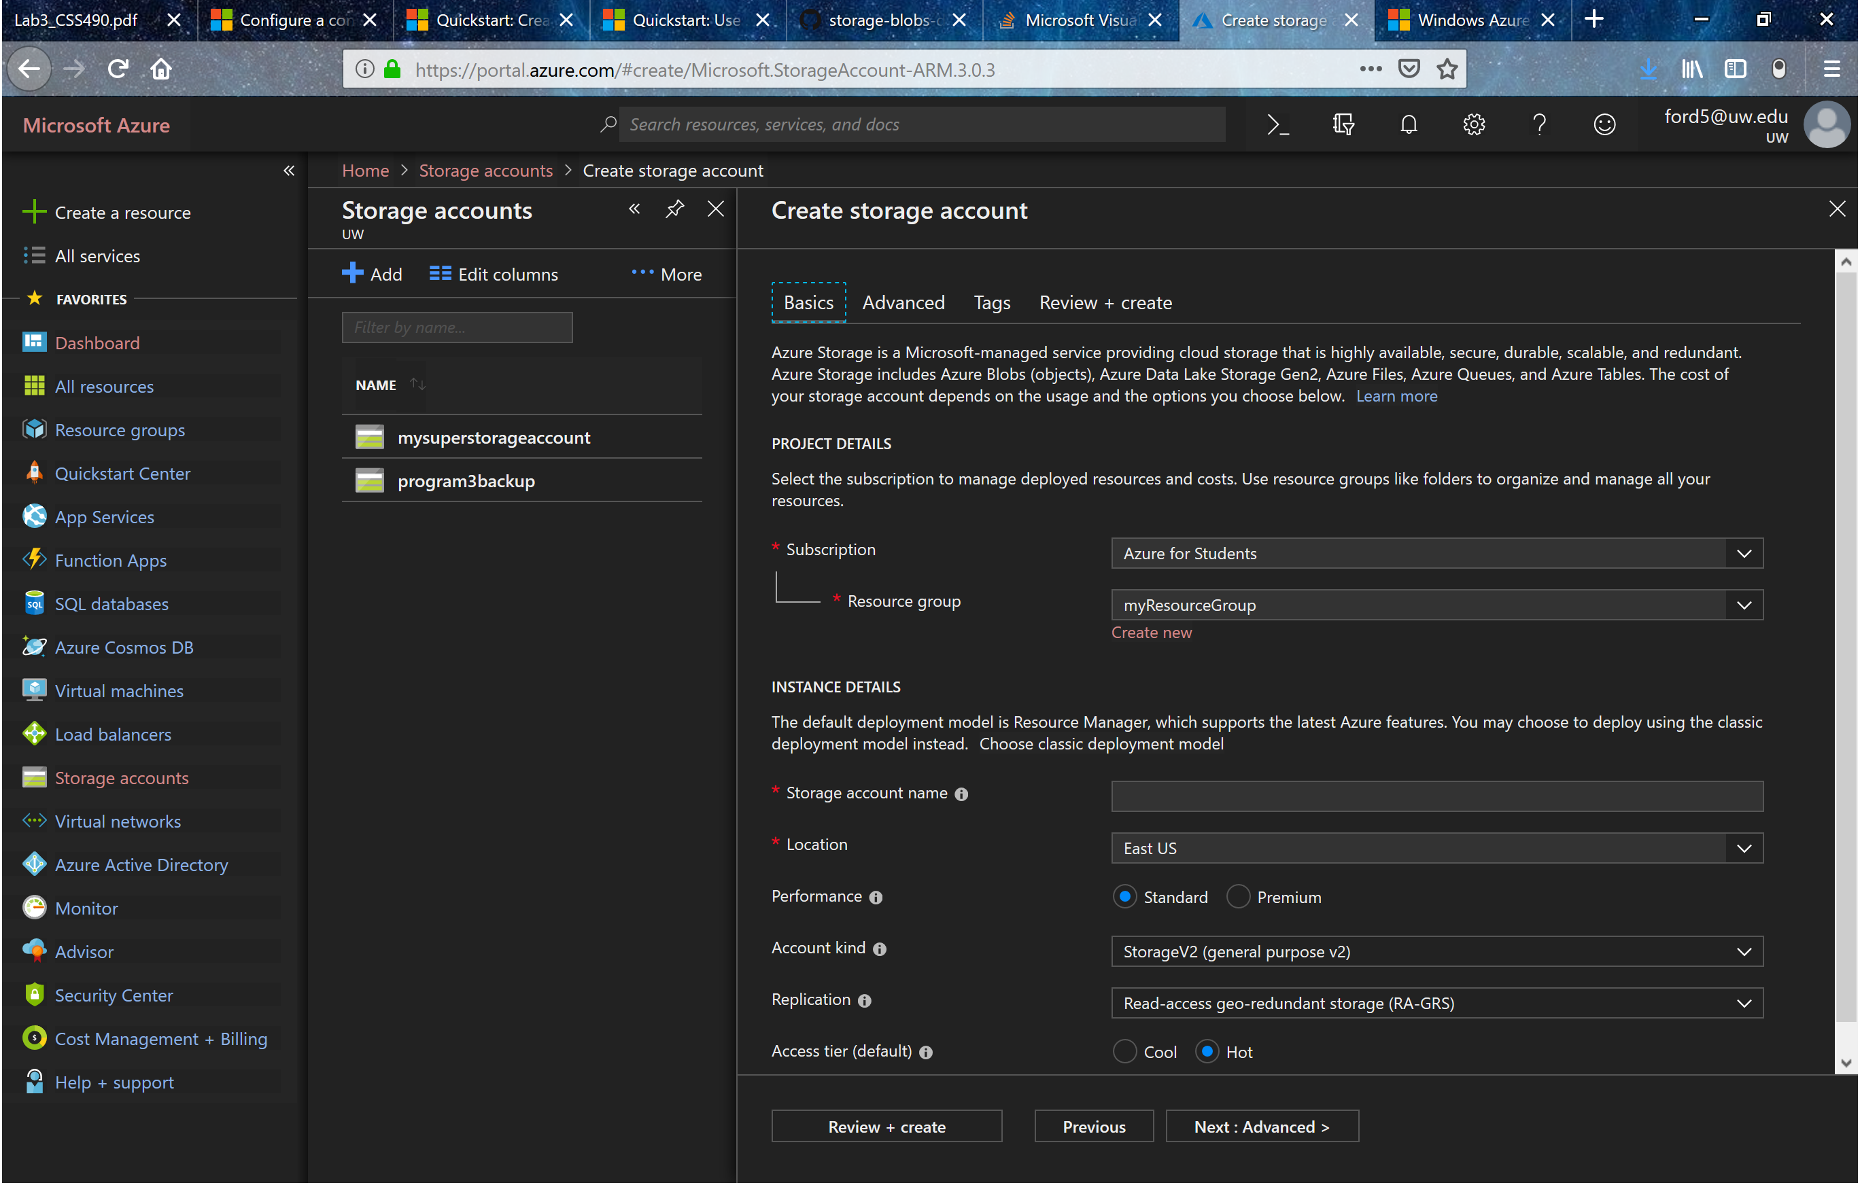

[More Info](https://docs.microsoft.com/en-us/azure/storage/common/storage-quickstart-create-account?tabs=portal)

**Creating Azure container**

1. Log in to the Azure Portal
2. Once on the dashboard click on the desired storage account
3. Click on ***Storage Explorer (preview)***
4. To the right a menu will open, right click ***BLOB CONTAINERS*** and select ***Create Blob Container***
5. Type in a name and select ***OK***

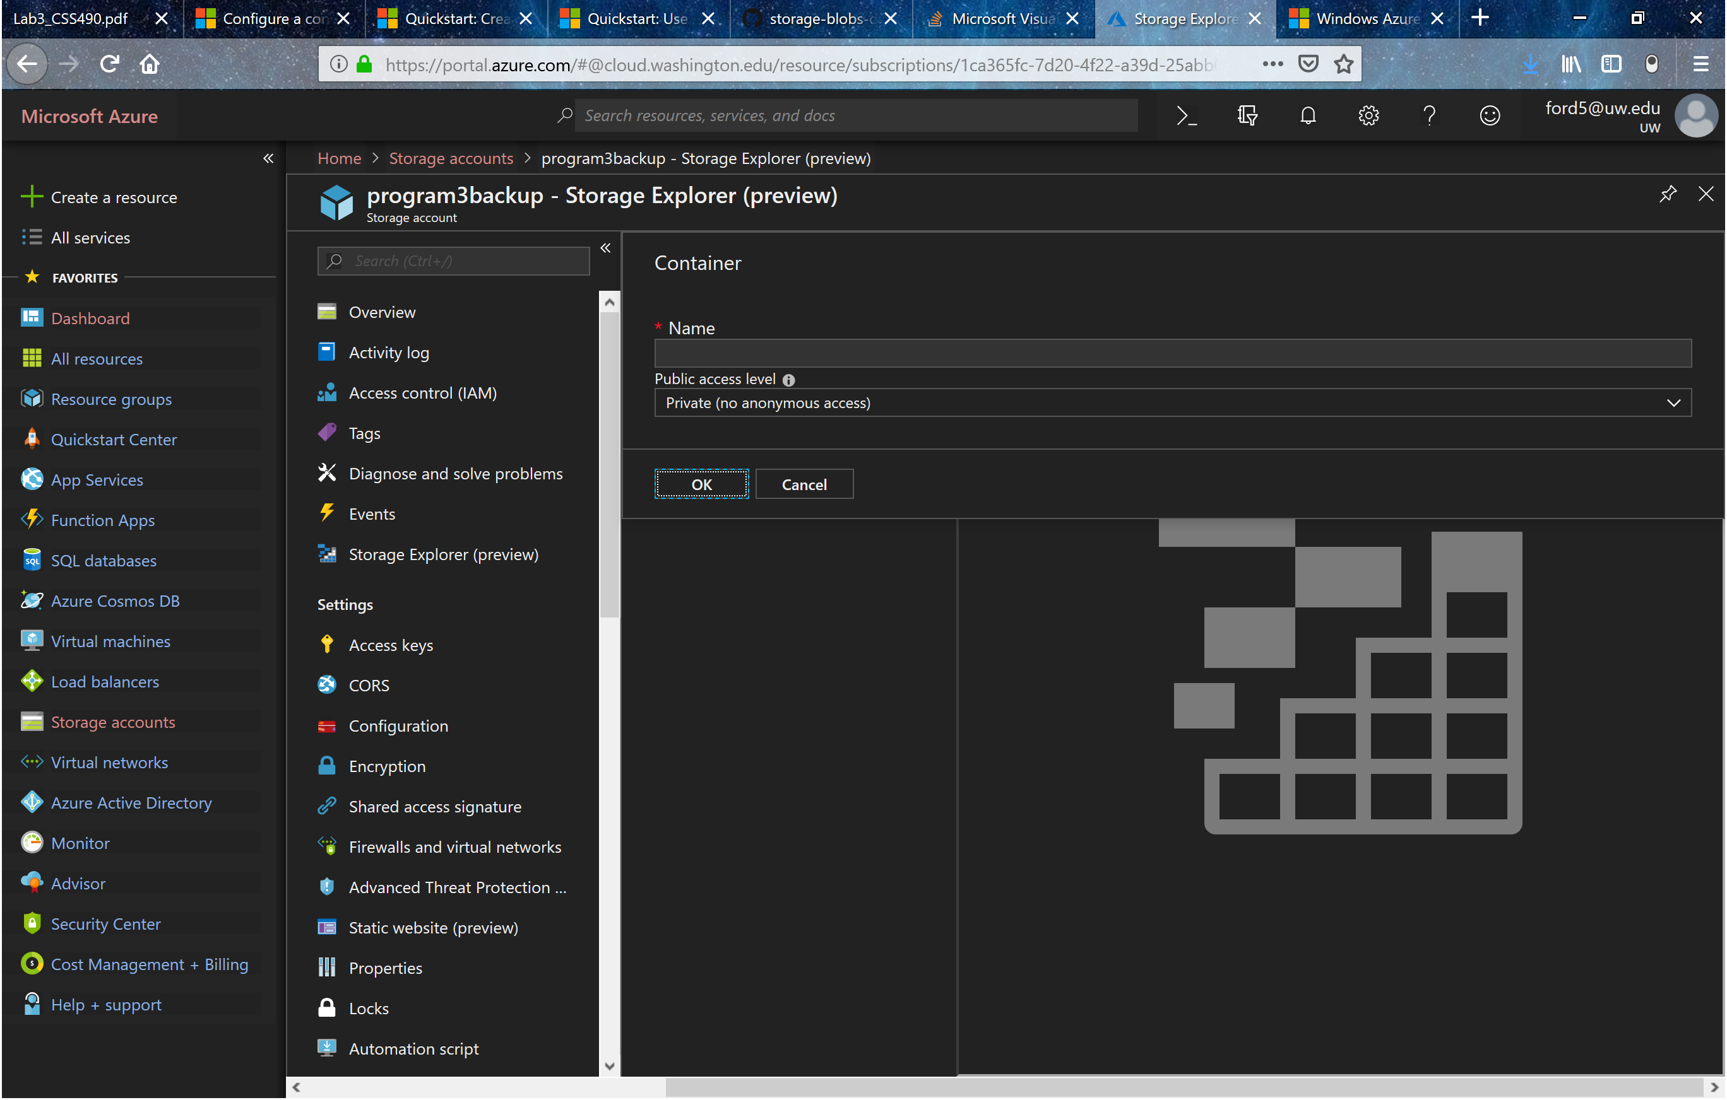

**Get storage account connection string**

1. Log in to the Azure Portal
2. Once on the dashboard click on the desired storage account
3. Click on ***Access keys***
4. Connection string will appear on the right and can be copy and pasted into program

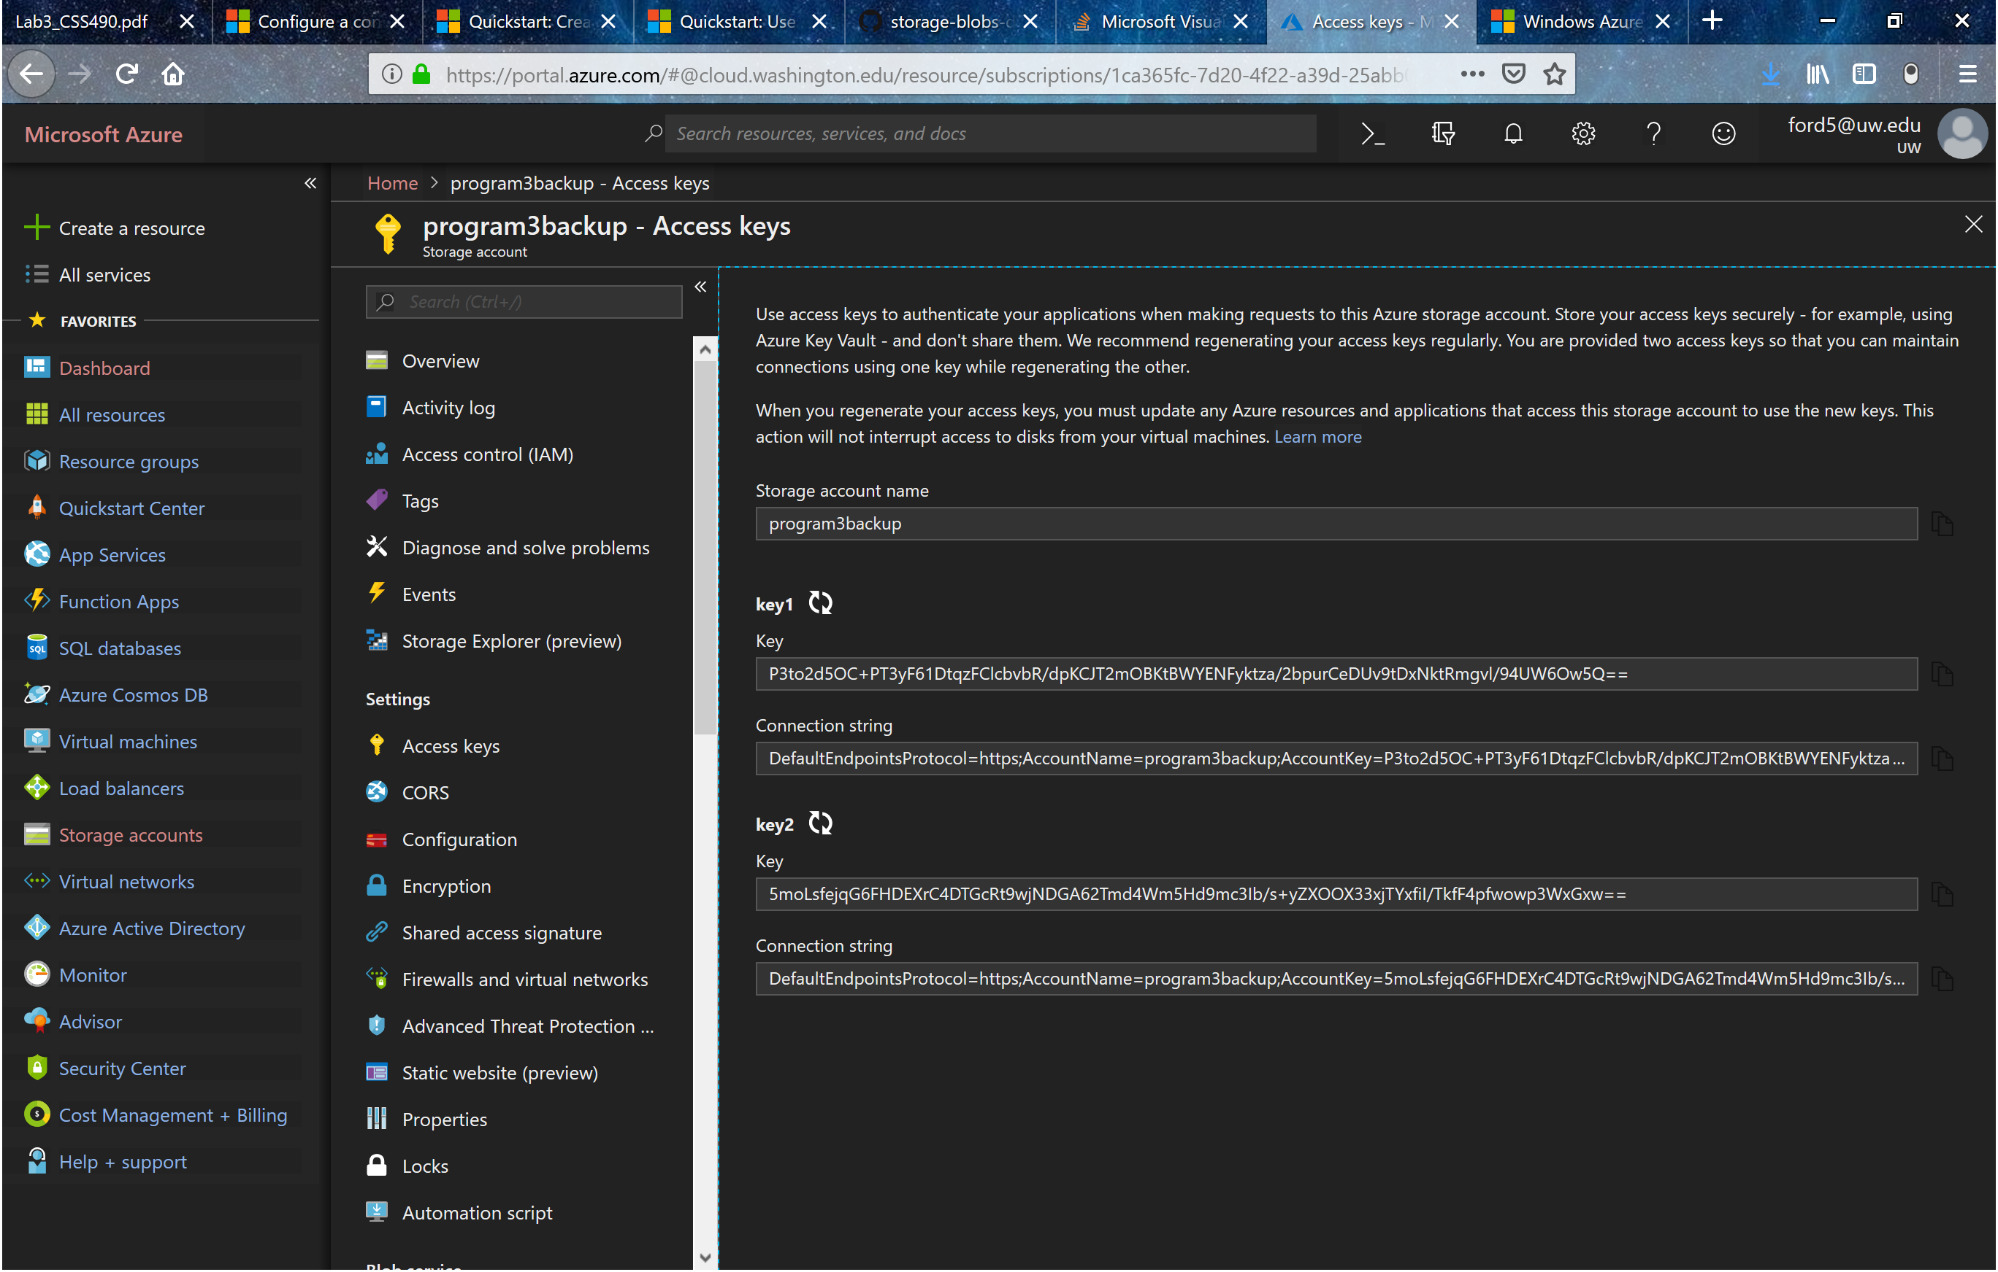

**Running the program**

1. Make sure that Program3.exe is I the same folder as Microsoft.Azure.KeyVault.Core.dll, Microsoft.WindowsAzure.Storage.dll, and Newtonsoft.Json.dll.
2. Open Program3.exe
3. Copy and paste the connection string for your test storage account
4. Enter the name of your test storage container
5. Enter a valid path starting from C:/ (i.e. C:\Users\chand\Desktop\Program3)
6. Files/folders that are new or modified will be uploaded to Azure
7. Will keep looping until you enter nothing or ‘exit’ to quit the program